SECTION 6: BUSINESS AUDIT

INTRODUCTION

Following the sectoral profiling of the economy in Makhado, this section analysis and focuses on the business sector of the economy. The purpose of this section is to report on the main findings of the business Audit conducted within the Makhado Municipal Area. The Business Audit was completed during the week of 21 to 25 February 2005 and subsequently captured on a computerised database. This data base was then analysed and the results are discussed in subsequent sections. The majority of the businesses are concentrated in Makhado and a grand total of 620 formal businesses were counted within the study area.

The emphasis of this chapter is on presenting an overview of the formal business audit. The headings employed in this chapter are:

- Process followed
- Salient features
- Implications for Economic Growth
- Problems and perceptions
- Conclusion

The different headings are discussed separately and where applicable, the development implications are identified and indicated.

PROCESS FOLLOWED

The result presented in this chapter is the outcomes/findings of the business audit that was undertaken throughout the Makhado area during 21 to 25 February 2005. During the audit, clear distinction was made between formal and informal businesses with separate questionnaires being formulated for each category.

SALIENT FEATURES

In order to provide an appropriate foundation afore the key issues emerging from the business audit is identified and discussed, the salient features of the formal business sector is presented. These salient features relate to specific characteristics such as:

- Sectoral Business Distribution
- Products and Services by Local Businesses
- Business Trends
- Perceptions of Businesses in Makhado Municipality

SECTORAL BUSINESS DISTRIBUTION

This part presents the distribution of businesses in the Study Area per economic sector. The Business Audit made provision for the classification of businesses into 16 economic sectors.

Table 6.1 illustrates the distribution of businesses in the formal sector of the local economy. The majority of the businesses in the Study Area are classified as retail shops, accounting for 40.5% of the formal business sector. These businesses are mostly located in Makhado. The second highest business category is motor vehicle sales and repair services (10.7%), followed by personal services (9.9%). Other important sectors include manufacturing (8.4%) and wholesalers (9.2%).

Table 6.1: Sectoral distribution of formal businesses, 2005
Sector | Percentage
Agriculture | 2.3
Mining | 0.8
Manufacturing (including printing) | 8.4
Construction | 0.0
Retail | 40.5
Motor vehicle related | 10.7
Wholesaler | 9.2
Restaurant / Takeaway | 4.6
Accommodation eg hotels, B&B's | 0.8
Transport | 1.5
Storage and warehousing | 0.8
Banking and loans | 0.0
Insurance (life, pension, medical) | 0.0
Property and real estate | 1.5
Business services (legal, professional) | 3.8
Social Services (education, health, sport) | 5.3
Personal Services (Dry cleaning, hairdresser) | 9.9
Total | 100
Source: Urban-Econ Business Audit, 2005

Formal businesses within the Makhado Municipal area are mostly medium to small shops selling everyday products.

This type of business does not create many employment opportunities. A standard size Shoprite Checkers, for example, would only cater for about 70 to 120 employees. This raises concern and begins to explain, in part, the high rate of unemployment in the area.

Table 6.2: Sectoral distribution of informal businesses, 2005
Sector | Percentage
Retail | 60.0
Snacks, sweets and fruit | 19.9
Personal Services (Dry cleaning, hairdresser) | 20.1
Total | 100
Source: Urban-Econ Business Audit, 2005

From the table above it is clear that the majority of informal traders are also involved with the buying and selling of retail goods. These goods are usually relatively cheap and purchased in small quantities. Profits are also low and only allow these business owners to survive on a day-to-day basis. The following table illustrates the income generated by the informal traders as well as the ownership of the informal business.

PRODUCTS AND SERVICES BY LOCAL BUSINESSES

FORMAL BUSINESSES

A detailed description of the products and services provided in the formal sector together with their percentage contribution can be seen in Table 5.10 below.

Table 6.3: Main Products and Services of surveyed formal businesses
Product/Service | Percentage
Bakery products | 3.1
Printing | 3.8
Cosmetics/perfume | 0.8
Plastic Products | 0.0
Steel Industries | 0.8
Forging and pressing | 1.5
Sale of tyres | 1.5
Insurance | 0.0
Alcoholic beverages | 6.2
Cell phones & accessories | 2.3
Motor vehicles | 3.8
Motor vehicle parts | 3.8
Jewellery | 0.0
Advertising | 0.0
Food Wholesale | 3.8
Food Retail | 6.9
Clothing & Foot ware | 9.2
Fuel sales | 0.8
Funeral Services | 3.8
Machinery | 3.8
Groceries | 3.8
Meat Products | 4.6
Pharmaceutical products | 1.5
Furniture and appliances | 6.9
Stationary | 1.5
Restaurants | 1.5
Medical (incl. Doctor & Dentist) | 0.8
Professional Services | 2.3
Other (Please specify) | 20.8
Total | 100
Source: Urban-Econ Business Audit, 2005

From the table above it is evident that clothing & foot ware, furniture and appliances, and food retail are by far the main products being traded in the formal sector. Other products and services representing more than 3% of the formal economy are meat products, machinery, funeral services, food wholesale, groceries and motor vehicle services. The rest of the economy is highly diverse in terms of products traded and services rendered.

INFORMAL BUSINESSES

Table 6.4 displays the sectoral distribution for the informal sector.

Table 6.4: Sectoral distribution of the Informal Sector
Sector | Percentage
Accessories | 5
Chicken | 5
Cooked Food | 10
Drafting House Plans | 5
Driving School | 5
Fruit and Vegetables | 30
Groceries | 25
Newspapers | 10
Shoe Repairs | 5
Total | 100
Source: Urban-Econ Business Audit, 2005

From Table 6.4 it is clear that the majority (55%) of informal traders are involved with the buying and selling or fruits and groceries. These goods are usually relatively cheap and purchased in small quantities. Profits are very low and only allow these business owners to survive on a day-to-day basis. The informal businesses are spread all over the study area, hence the difficulty to capture all the informal businesses due to their timeously existence.

Table 6.5: Weekly income of informal businesses and business ownership
Income Category | Percentage
R0 - R200 | 40
R201 - R400 | 30
R401 - R600 | 19
R601 - R800 | 11
Total | 100

Figure 6.1
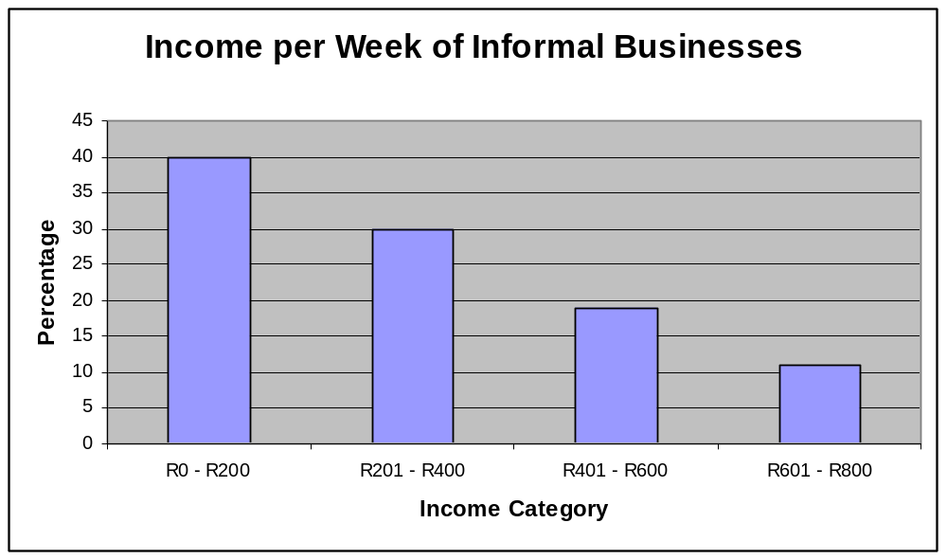

Source: Urban-Econ Business Audit, 2005

Table 6.5 above indicates that the majority of the informal traders earn between R0 and R200 per week. It is therefore evident that none of these business types are usually very profitable on small scale but will benefit from marketing and small business development services. Employment by these services is also very low and usually only providing employment for one or two people.

The quality of employment in the informal sector is also of concern (i.e. less personal income and skills development than in the formal sector). Table 6.6 illustrates the major reason for people working as informal traders.

Table 6.6: Reason for starting informal business
Reason for informal trade | Percentage
Unemployed | 74
Wanted own Business | 26
Total | 100
Source: Urban-Econ Business Audit, 2005

It was found that approximately 95% of the informal traders interviewed are doing it as their full-time job whereas the remaining 5% do it on a part-time basis.

Table 6.7 illustrates clearly that level of education is a major concern in the Study Area.

Table 6.7: Highest Qualification of Informal Traders
Qualification of Informal Traders | Percentage
No Schooling | 15
Some Primary | 10
Completed Primary | 10
Some Secondary | 15
Completed Secondary | 5
Metric | 35
Higher Qualification | 10

Figure 6.2
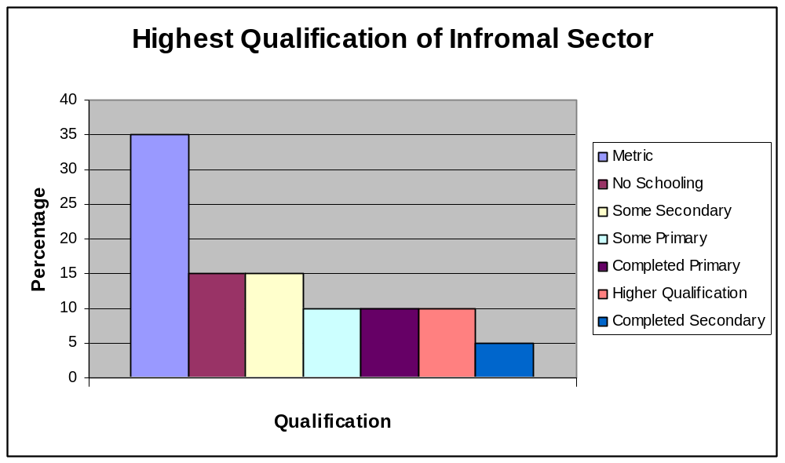

Source: Urban-Econ Business Audit, 2005

From the table above it is evident that the majority of informal traders have some form of formal qualification. Cognisance must be taken of the fact that approximately 35% of the informal traders have completed primary schooling, 20% completed secondary schooling, 35% have a matric qualification whereas 10% have a higher qualification.

BUSINESS TRENDS

Local business trends provide a good indication of the tendency and the direction the local economy is moving. Business trends over the last five years are displayed in Table 6.8 below. It reflects on current trends such as turn over, physical space, market share, employment and production.

Table 6.8: Business Trends over the last five years (1999-2004)
Trends | Large increase | Small increase | Same | Small decrease/ decline | Large decrease/ decline | Total
Turnover | 23.2% | 42.9% | 22.3% | 6.3% | 5.4% | 100%
Production | 17.7% | 40.6% | 29.2% | 10.4% | 2.1% | 100%
Employment | 12.4% | 33.3% | 41.0% | 6.7% | 6.7% | 100%
Market share | 13.3% | 33.7% | 43.9% | 5.1% | 4.1% | 100%
Physical space | 13.3% | 16.2% | 60.0% | 4.8% | 5.7% | 100%

Figure 6.3
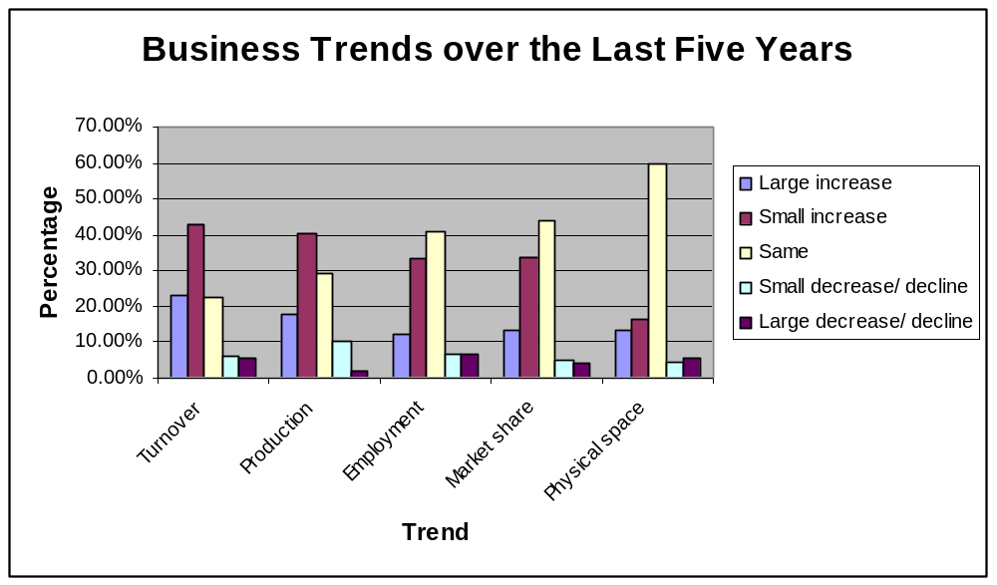
Source: Urban-Econ Business Audit, 2005

According to Table 6.8 the majority of the businesses experienced an increase in their turnover during the period. The same applies for production. The majority of the businesses had no increase in the number of employees and their market share and physical space remained the same. It is however worrying that approximately 14% of the businesses interviewed had to reduce their number of employees, hence the trend of out migration that was illustrated in a previous section.

Table 6.9 illustrates expected future business trends over the next five years in terms of the same criteria.

Table 6.9: Expected Future Trends over the next five years
Trends | Large increase | Small increase | Same | Small decrease / decline | Large decrease / decline | Total
Turnover | 37.2% | 33.6% | 13.3% | 5.3% | 10.6% | 100%
Production | 34.7% | 29.6% | 23.5% | 1.0% | 11.2% | 100%
Employment | 22.2% | 21.3% | 38.0% | 6.5% | 12.0% | 100%
Market share | 25.7% | 24.8% | 39.6% | 5.0% | 5.0% | 100%
Physical space | 25.2% | 19.6% | 47.7% | 1.9% | 5.6% | 100%

Figure 6.4
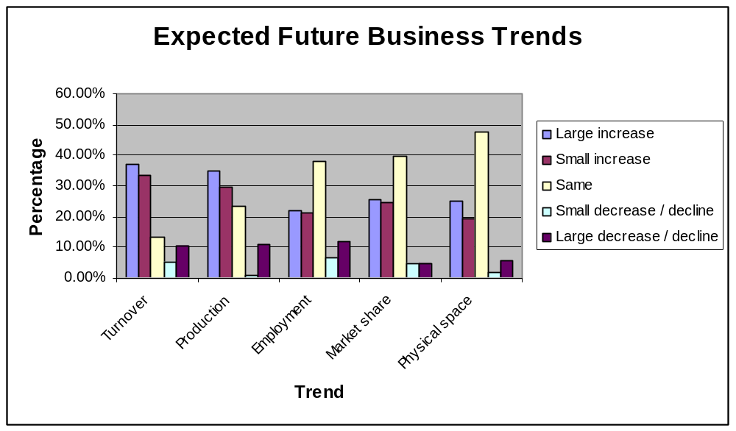

Source: Urban-Econ Business Audit, 2005

Table 6.9 illustrates that business respondents are positive about doing business in the Study Area over the next five years. Approximately 70% of businesses indicated that they expect to increase their turnover and production over the next five years. The trend of reducing employees is expected to continue over the next five years.

From the above it can be concluded that jobless growth are set to take place over the next five years. Jobless growth refers to the increase in turn over per year and a decrease in the number of people employed by the business. Possible reasons for jobless growth may include the following:

- Low levels of skills
- Low levels of education among the local population
- Loss of employment due to mechanisation and more effective business processes.

PERCEPTIONS OF BUSINESSES IN MAKHADO MUNICIPALITY

Table 6.10 indicates the major reasons of businesses locating in the Study Area. The most important reasons for local businesses locating in Makhado include, inter alia, the following:

- Proximity to local markets
- Local accessibility
- Suitable premises

Table 6.10: Reasons of Businesses locating in Study Area
Locational Factor | Yes | No
Proximity to local markets | 60.0% | 40.0%
Proximity to regional markets | 42.2% | 57.8%
Availability of staff | 42.2% | 57.8%
Wages and salary levels | 37.0% | 63.0%
Proximity to suppliers | 35.6% | 64.4%
Municipal rates and taxes | 32.6% | 67.4%
Local accessibility | 59.3% | 40.7%
Regional accessibility | 43.0% | 57.0%
Suitable premises | 59.3% | 40.7%
Close to home | 38.5% | 61.5%
Purchase price of land | 20.7% | 79.3%
Historic reasons (always have been here, don't know other areas) | 24.4% | 75.6%
No/little competitors | 24.4% | 75.6%
Security needs | 47.4% | 52.6%
Rentals payable | 40.7% | 59.3%
Potential for expansion | 33.3% | 66.7%
Concentration of "know-how" | 23.0% | 77.0%
Proximity to "housing" | 25.2% | 74.8%
Source: Urban-Econ Business Audit, 2005

Other locational factors which favour the local businesses in Makhado include:

- The vibrant Central Business District (CBD) of Makhado
- The close proximity of businesses to the taxi rank provides good and efficient access of employees to their work
- The CBD is an established business district which has a vibrant trade component to it

Cognisance should be taken of the fact that approximately 10% of businesses interviewed considered relocating to another place. Table 6.11 below illustrates this.

Table 6.11: Predictions of businesses’ decisions in Makhado
Option | Percentage
Relocating Elsewhere | 9.2
Staying | 86.2
Selling Business | 2.8
Closing Down | 1.8
Source: Urban-Econ Business Audit, 2005

It is evident that the majority of businesses will remain in the study area. What is worrying though is that approximately 14% of businesses interviewed want to relocate, sell or close down their business.

IMPLICATIONS FOR ECONOMIC GROWTH

The study area is predominantly characterised by a mix of urban and rural economies, thus ranging from relatively strong economic performance to relatively isolated rural settlements with high levels of poverty. Given the slow growth of the economy and the growing population in the study area, the level of unemployment is set to grow. From the socio-economic and economic analysis in the preceding sections, it is evident that approximately 75% of the population earns no form of income. The scarcity of employment opportunities, higher order shopping and business facilities within the Study Area forces people to travel over long distances, paying a substantiate amount of their income for transport. This has affordability implications in the context of persistent low incomes.

Although a range of municipal and other services (infrastructure, schools, clinics, social services, etc.) are available in the Study Area, there is a general lack of sufficient facilities such as retail, commercial, industrial opportunities that could employ sufficient numbers of people and provide acceptable range, prices and quality to ensure that money is spent in the area. Although there are sub-regional nodes, corner shops and spazas for the daily needs of local communities at various scales, there appears to still be a need for an industrial node where agricultural products can be processed and value added. This was a very important concept which came to the fore from the interviews with local stakeholders in the agricultural sector. This could provide for substantial employment opportunities and inflow of capital into the Study Area.

Areas close to the major transport spines generally have access to the most engineering service infrastructure, e.g. telecommunication, electricity and water. It should be noted that although the percentage of households with access to flush toilets have increased since 1996 to 2001, the majority of households still make use of pit latrines or have no access to sanitation facilities at all. As one moves away from the major routes deeper into rural settlements the level of services declines (instead of taps on site, one starts coming across communal taps or boreholes). Thus the further one moves from the activity/transport spines, the poorer the respective town’s/settlements’ economic growth prospects appear to become.

From the socio-economic analysis it was evident that the majority of the dwelling types in the Study Area are formal in nature. Most of the Study Area generally appears to have adequate access to social services. However, substantial public investment is required to upgrade engineering services and transport infrastructure if the Study Area’s economic growth prospects are to improve.

The Study Area does therefore not have the ability to provide in all the needs of its residents, which raises concerns about the economic sustainability and viability of the local economy. The sheer numbers of the local population are not enough to drive the economy on a growth path simply because the surrounding local economies are large enough and close enough to stifle any competition from within the Study Area.

Interviews held and surveys conducted found that in general people are positive about their area and only a small minority have immediate plans to relocate somewhere else. Although unemployment rates are high and income levels are generally low, the standard of living

STUDY AREA OPPORTUNITIES AND CONSTRAINTS

The major constraints and opportunities for the Study Area can be summarised as follow:

Constraints

From the preceding analysis it was illustrated that the Study Area produces only 7.55% of the total GVA in Limpopo which implies that its economy is very small in the provincial context and that very little of production that occurs in the province occurs within the Study Area.

A nearby 78% of the labour force in the Study Area is unemployed. The sustainability of the local economy and the future viability of the Study Area are in danger of stagnation, and should this situation not be reversed, general economic decline and an increase in the unemployment rate is guaranteed. The percentage (15.5%) of people in the formal sector of the Study Area is also not representative of a strong economy.

The occupation of the labour force indicates that many workers are unskilled in the Study Area. Education levels are also very low in the Study Area, implying that local people have a poorer chance at obtaining higher-level job opportunities and consequently they have a lesser chance of earning higher-level incomes. The majority of the population is heavily reliant on primary sector work opportunities which fluctuate over time.

A dependency rate (2001) of 1.83 in the Study Area means that every local person that earns an income has about 2 people who are dependent on the same income. The large available pool of labour makes the area attractive for industrialists but the lack of development incentives is keeping potential investors away.

The following section highlights the constraints obtained from the interviews with local stakeholders. The opinions include, inter alia, the following:

- According to results from local stakeholder interviews, numerous development decisions affecting the well-being of the local economy are made at the expense of ignoring local stakeholders or “indigenous” knowledge
- Development of local economic opportunities cannot occur in the interest of the local population without the integration of local participants and communities - cooperative management in the local community
- Insufficient land is made available for housing development and when so, infrastructure is poor or not attended to
- Blocked correspondence channels inhibit the development potential of future projects compromising the sustainability of such projects
- Land tenure processes and the resulting shift of productive to non-productive land in the hands of poorly skilled farmers, is of major concern to commercial farmers
- Focused funding on Tourist Association development should receive greater municipal support than individual tourist projects - Communication channels between council and the community are blocked
- Poor service delivery and frequent power and water problems frustrate local residents
- Growth is limited by lack of financial resources and skills namely managerial, leadership and financial skills
- Bilateral trade agreements and strong Rand hampering growth in agri-industry
- There is a distinct lack of entrepreneurship, capital and other economic inputs that would be required to initiate economic development projects in the Study Area
- An indication of disunity, political disagreement also contributes unfavourable development conditions.

Other more generic constraints include the following:

- High rentals of premises
- Road infrastructure is very poor
- Some of the businesses’ premises are to small
- Crime is a major problem to some local businesses
- Insufficient parking
- Low electricity voltage to businesses
- Municipal rates and taxes are to high
- A lack of business opportunities and opportunities to make progress
- No support from local government
- Water supply is very poor
- Availability of skilled staff
- HIV/AIDS
- Land claims
- Little government funding for local water projects
- There is no marketing campaign for local businesses from Municipality
- There is no support from retail enterprises to promote retail
- Poor government financing
- Informal street traders
- Competition is very high/businesses replicate

Opportunities

The comparison with the provincial economy shows that the Study Area experienced relatively strong sectoral growth in its Agriculture, forestry and fishing; Wholesale & retail trade; catering and accommodation; Community, social and other personal services; and Transport & communication sectors.

Of these above-mentioned sectors, the Study Area has a comparative advantage in the community, social and other personal services; wholesale & retail trade; catering and accommodation; and transport & communication sectors. Should the local economy be opened up and fully integrated with the wider region, the potential for future growth can be substantial. A positive indication of community pride also contributes to a stable environment.

The following section highlights the opportunities obtained from the interviews with local stakeholders. The opinions include, inter alia, the following:

- The formation of an organized development platform is required to maximize local benefits and deter unwanted developments – i.e. pro-active consultation processes between local business and the Municipality
- Opportunities in tourism development and agro-processing of agricultural products can be promoted. Investment in the agriculture sector makes significant improvements to food security, decreasing household expenditure, and decreases dependence on wage labour. It is assumed that there is still room for improved effectiveness of the farmers and, given appropriate aid (funding, training for emerging farmers), the agricultural sector may grow in future
- Greater development in the housing sector could be promoted
- With regard to local timber productions, the potential use of such timber has not been fully realized. More needs to be done from a marketing perspective to allow this local resource to benefit the economy. Opportunities exist within this local industry in as far as support services are concerned. Training of local people in forestry management methods offers the opportunity to subcontract as registered businesses to commercial foresters. This includes:
      - Fire fighting
      - Slashing
      - Road maintenance
      - Forestry maintenance
      - Bush culture
      - Harvest
- The growth of adventure tourism in the area backed by effective Community Tourism Association management - The promotion of and anti-pollution campaigns and a clean environment. Preservation of local green areas and maintenance thereof for community benefit
- Recycle excessive amounts of waste plastics, cans, bottles and paper
- When projects are awarded to regions, labour intensive projects should be awarded in order for optimal job creation opportunities
- Gardening projects could be implemented in the respective regions
- Farming and timber production

From the above-mentioned opportunities it can be concluded that there is a considerable potential in the developing and supporting of local entrepreneurs and local businesses rather than the development of large-scale development projects.

CONCLUSION

In this section the economic situation of the Study Area in relation to Limpopo Province and the economic sub region was analysed. It was found that the local economy is relatively weak and small when compared to surrounding economies and that external intervention will be required to boost the Study Area economy. The summary of constraints and opportunities shows that although the local economy is small there are a number of opportunities which, over the medium to long term, can bring about growth in the Study Area.

